Highly flexible self-adhesive zinctape
Technical Data Sheet

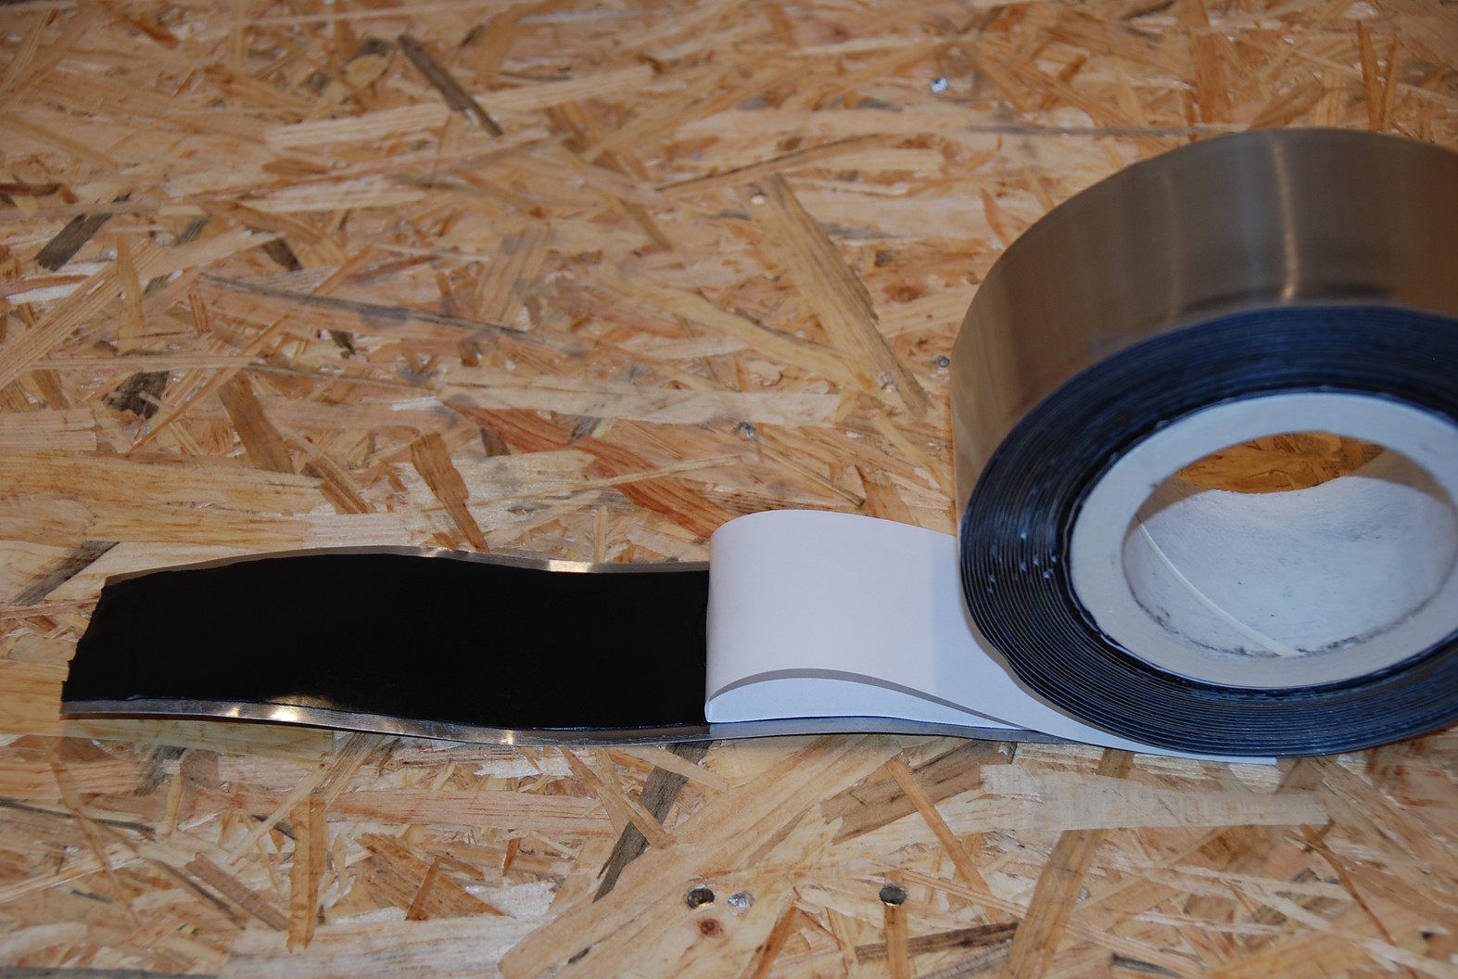

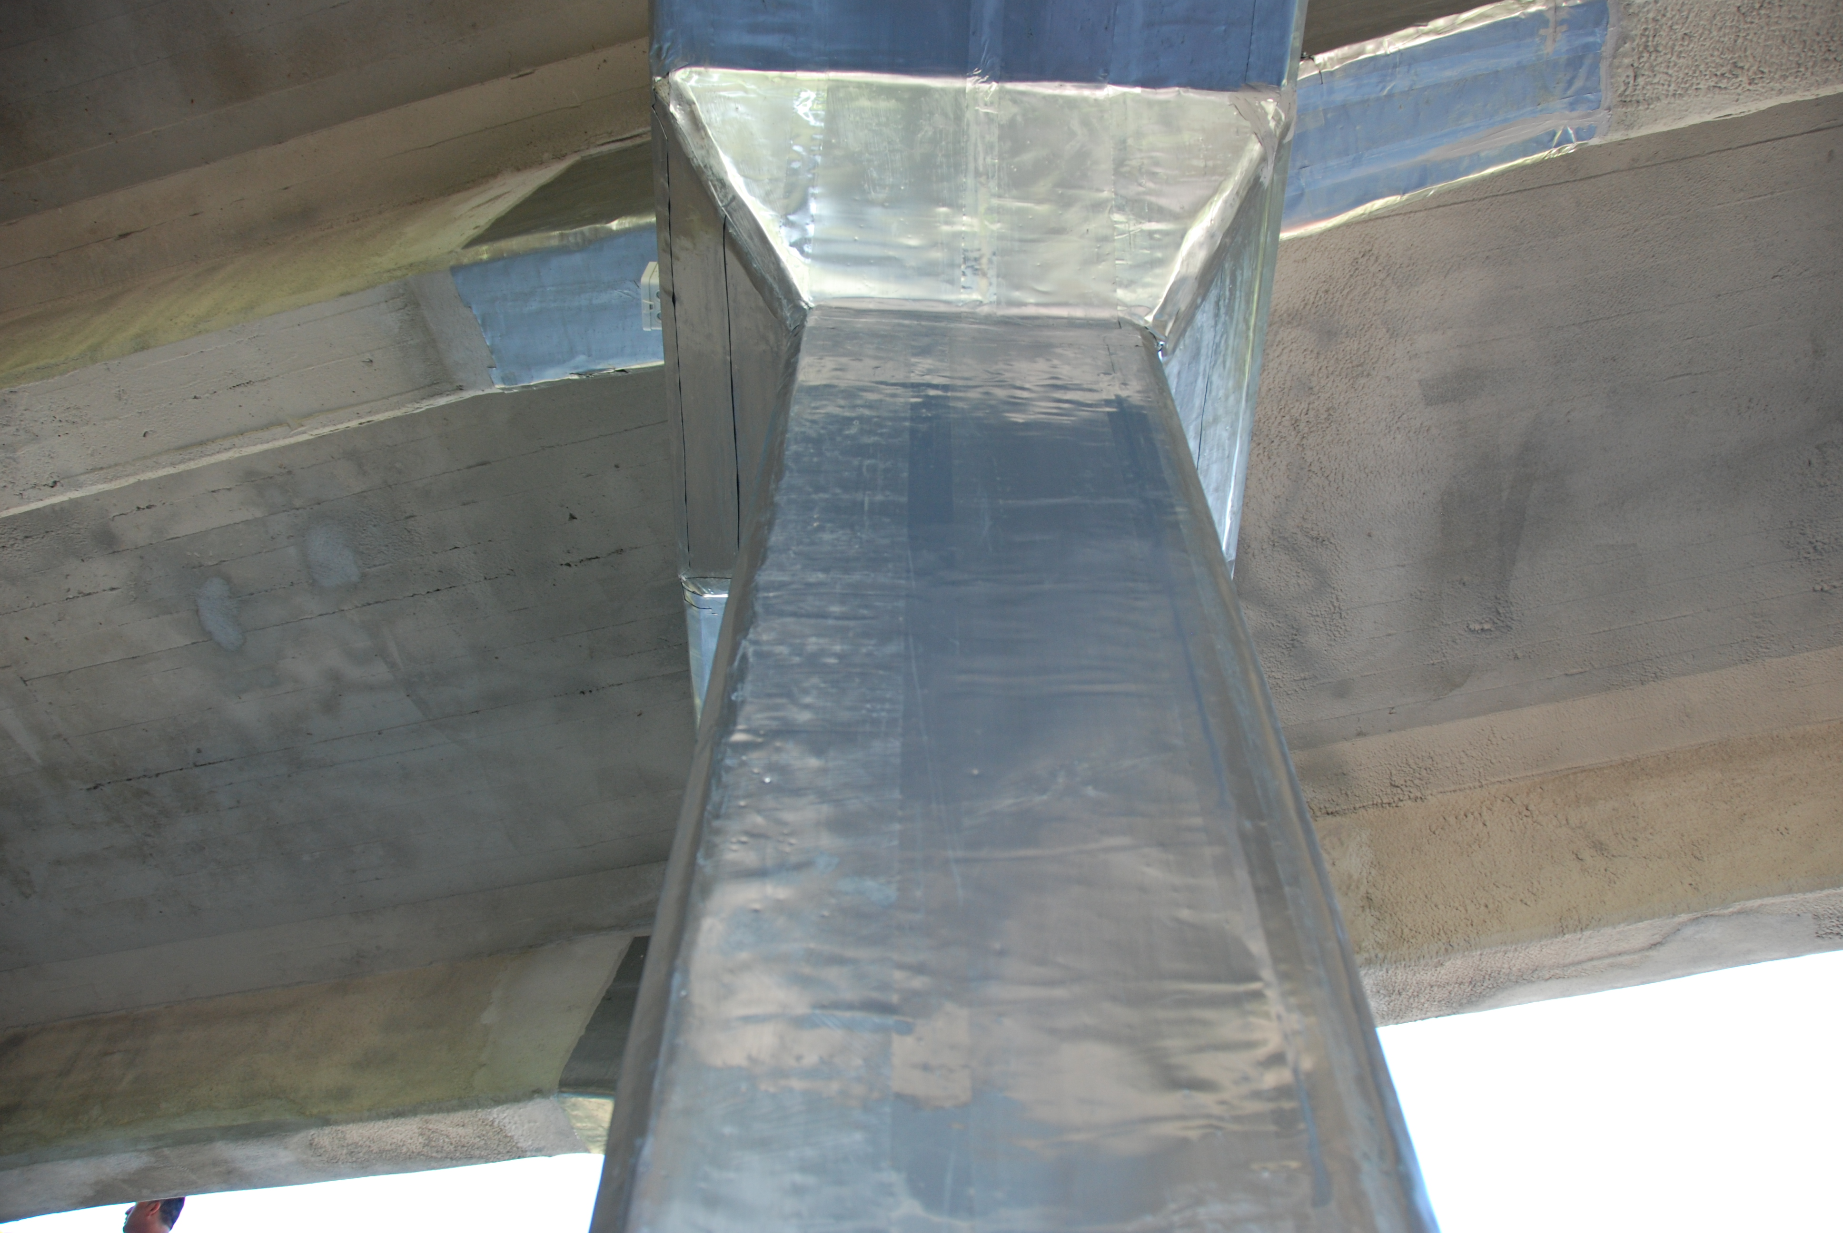

Product description

Highly flexible self-adhesive zinctape consists of a 150 micron zinc sheet with a high tack 1mm thick butyl rubber adhesive highly resistant to gas or water vapors. Adheres to all metals and porous materials like concrete.

Can be used as a waterproof flashing tape or membrane for sealing openings in exterior walls.
*Recommended with ZLA to seal the ZLA overlapping and edges.

For optimum adhesion, all surfaces should be properly prepared and must be free from dust and grease and substrates must be dry.

Features :

- Aggressive tack even at low temperatures.
- Good adhesion to most surfaces.
- Recommended service temperature : -40 to +90ºC
- Excellent UV & ageing resistance (in excess of 20 years).
- High shear strength.
- High peel strength.
- Solvent free.
- Comes with a peel-off liner, release-coated paper.

Material | Dimensions
Zinc foil thickness | 150 micron
Butyl rubber adhesive | 1 mm
Zinc foil width | 60 mm
Butyl rubber width | 50mm
Standard roll length | 10 meters

CorrPRE Engineering BV, Zuidbaan 509, 2841MD Moordrecht, Netherlands
Revision Nr. Revision date Approved
02 19th March 2017 R. Giorgini

All technical data stated in this Technical Data Sheet are based on laboratory tests. Actual measured data may vary due to circumstances beyond our control. The information, and, in particular, the recommendations relating to the application and end-use of CorrPRE's products, are given in good faith based on CorrPRE's current knowledge and experience of the products when properly stored, handled and applied under normal conditions in accordance with CorrPRE's recommendations.

